CREW REGISTRATION 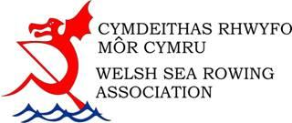
CLUB
CREW NAME
Club A, B, C etc
BOAT NAME
BOAT TYPE
BOAT COLOUR |  |  |  |  |  |  |  | BOAT NUMBER
CLASS ENTERED (Please tick)
Seniors |  |  |  | Women |  |  |  |  |  | Mixed
Senior Vets |  |  |  | Women Vets |  |  |  |  |  | Mixed Vets
Senior Super Vets |  |  |  | Women Super Vets |  |  |  |  |  | Mixed Super Vets
Novice
JUNIORS (Please tick)
Open u18 |  |  |  | Boys u18 |  |  |  |  | Girls u18
Open u16 |  |  |  | Boys u16 |  |  |  |  | Girls u16
U14 participation
CREW MEMBERS (Please list)
Cox |  |  |  |  |  |  |  |  |  |  | Age of junior rower on the day of the race
Stroke
3
2
Bow
I declare that all crew are members of an affiliated club and registered with WSRA and agreed to being photographed
Signed |  |  |  |  |  | Position
PLEASE MAIL YOUR REGISTRATION FORM TO claude.secretarybrc21@gmail.com

